Researchers Bring Together Industry Groups: “Next Generation Packaging, Kitting, and Palletizing: Can one robot do it all?” at MODEX 2012 in Atlanta, GA.

In the material handling community, three disparate subgroups exist in the areas of kitting, packaging, and palletizing. Currently, these operations are performed by a mix of automated and manual systems with very limited market penetration of automated systems into small- and mid-sized companies. Lack of automation is due to difficulties in using today’s generation of robots for tasks that include requirements such as small lot sizes and product variability. In addition, infrastructure requirements and high levels of required expertise make them cost prohibitive. A major contributing factor is that current manufacturing robots have little or no understanding of the world around them and no capability to dynamically change their actions if the environment or task changes. This restricts them to operate in highly constrained environments and makes it difficult to change from one task to another.

EL researchers Stephen Balakirsky, Craig Schlenoff, and Raj Madhavan led a seminar titled “Next Generation Packaging, Kitting, and Palletizing: Can one robot do it all?” as part of the Material Handling Industry of America’s (MHIA) MODEX show in Atlanta GA. This seminar explored the idea that systems that are capable of modifying their behavior by generating and adapting plans will overcome these limitations and that these systems will require detailed knowledge of, and a consistent representation for both the manufacturing environment and the plans. The seminar also explored ways to exploit the significant similarities in packaging, kitting, and palletizing, in the way their requirements are represented, and in how their performance is evaluated.

The seminar was attended by over 20 end-users, robot vendors, system integrators, and researchers. It consisted of six invited talks by speakers from NIST and industry, followed by a general discussion. The group discussed how to collaborate, with industry participants from all sectors soliciting NIST’s leadership in developing a data representation to describe product handling for packaging, kitting, and palletizing. The participants recognized that there is a large overlap in the technologies needed for packaging, kitting, and palletizing, and decided to set up an informal working group that will use mailing lists to identify issues to jointly address. A subset of the participants also agreed to act as an industry advisory panel for the NIST project. The NIST participants are preparing a report on the findings of the workshop that will be circulated amongst the attendees and the industrial community.

Possible Pictures for article:

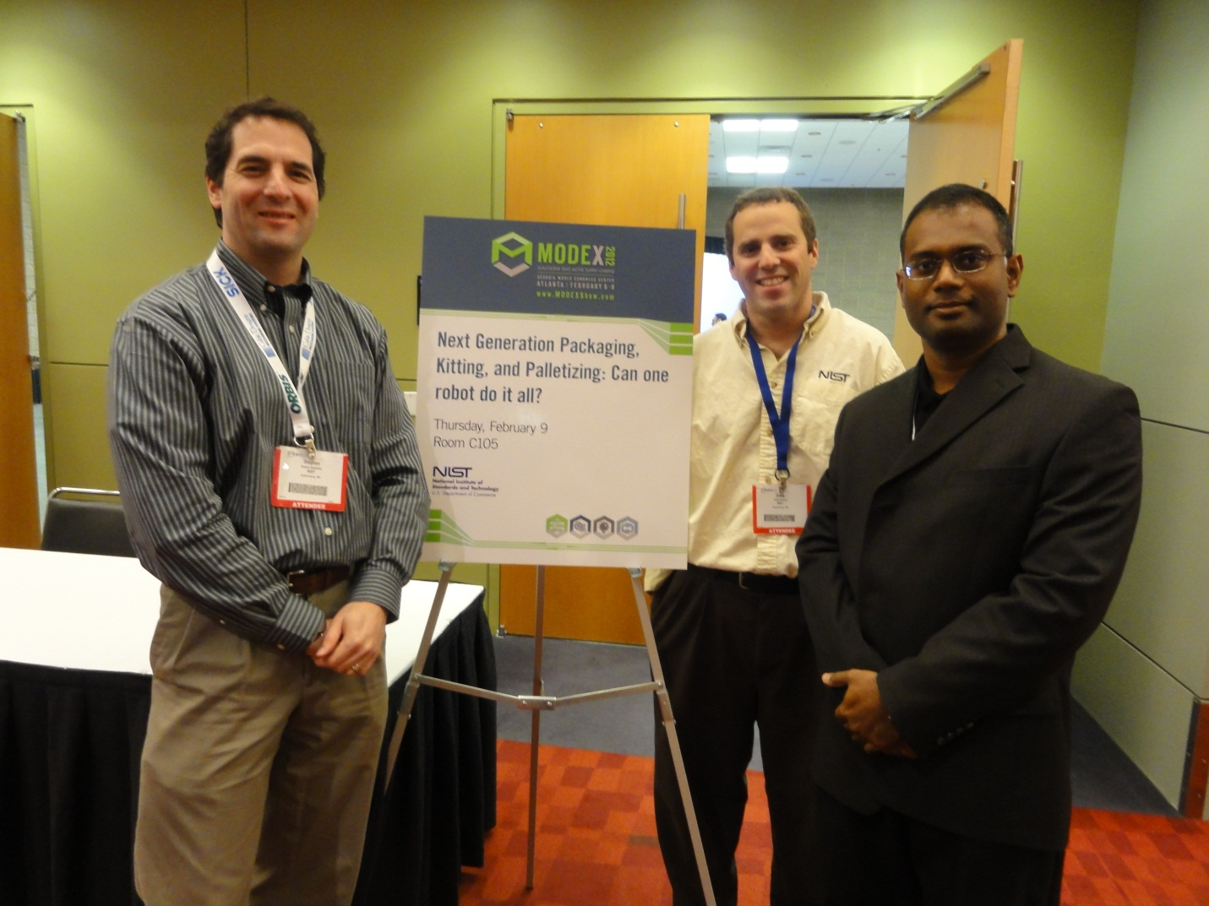

Figure : Nist Researchers Stephen Balakirsky, Craig Schlenoff, and Raj Madhavan hosted the "Next Generation Packaging, Kitting, and Palletizing: Can one robot do it all?" workshop at MODEX 2012 in Atlanta, GA.

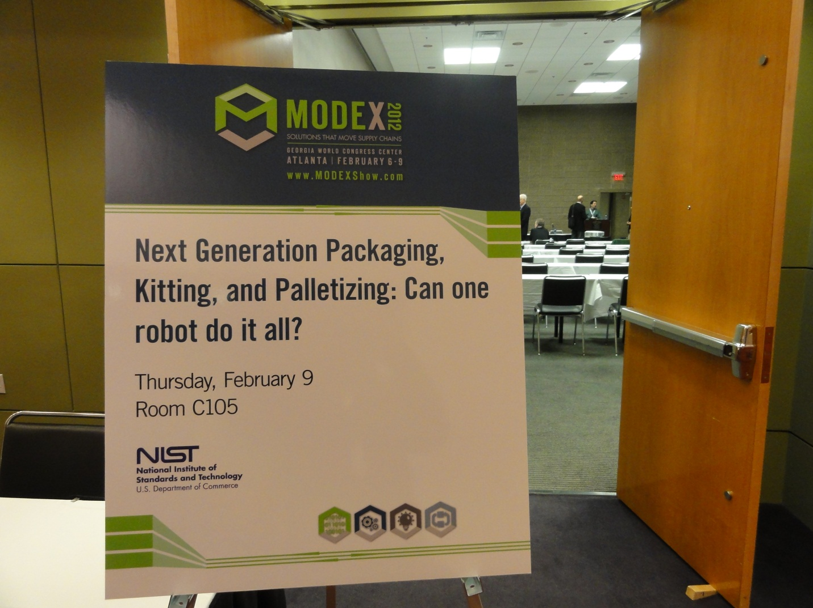

Figure : Conference where workshop was held.

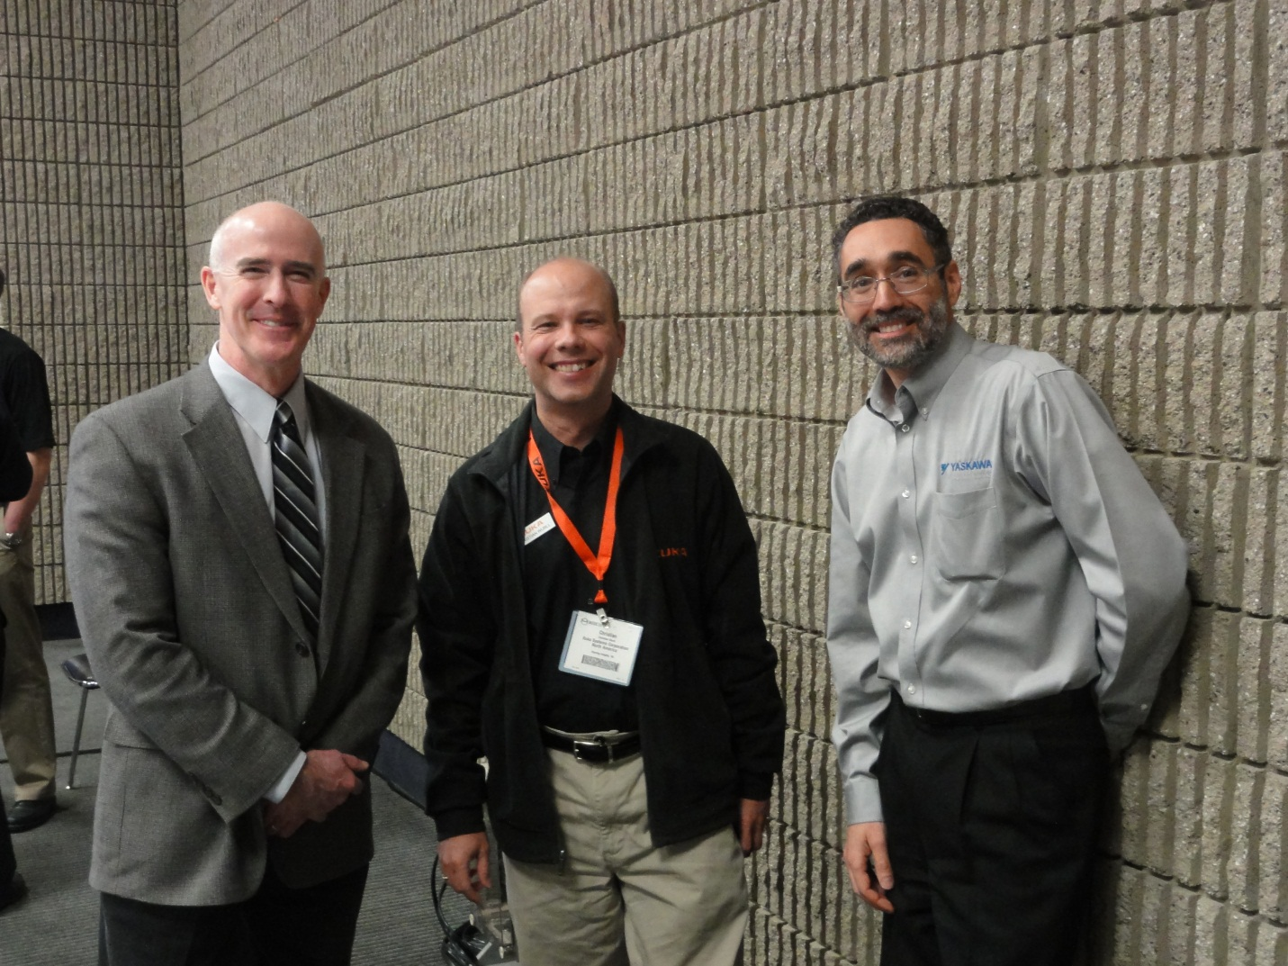

Figure : A rare event! Representatives from Fanuc, Kuka, and MotoMan robotics smiling, and in the same room together! We would need to get photo releases from them, but I believe that I could arrange that.